

**OCTOBER 21–29, 2021, IMSP, DANGBO, BENIN**

**INTRO**

After the first edition that gathered 106 scholars and practitioners from 16 countries, and addressed OR techniques and methods with applications in different areas, particularly health, climate, environment, telecommunications, logistics, and finance, the third edition will emphasize on Supply chain management and inclusive financial engineering to foster discussions around the African Center of Excellence Impact goals to impact the local enterprises.

Deadline for applications, research abstracts, papers and e-posters submission: 30 June 2021

**International Scientific Committee:**

* **Luciana Buriol**, UFRGS & IFORS, Brazil
* **Sébastien Le Digabel**, GERAD & Polytechnique Montréal, Canada
* **Andréa Cynthia Santos**, INSA Rouen, ISEL, France
* **Guy DEGLA**, IMSP, UAC, Dangbo, Benin

**Local Organizing Committee:**

L. Todjihounde, J. Tossa, J. Koudi, A. Dembélé, O. Sossoukpe, I. Zounnon, J. Djivoedo, G. Aihonnou, G. Amadji, M. Gomez

Further information: <https://www.ceasma-benin.org/>

Contact: [ortasa@imsp-uac.org](mailto:ortasa@imsp-uac.org) +229 61 81 67 27 (Mrs. Inès Zounnon)

**MAIN SPEAKERS AND WORKSHOPS TOPICS**

1. **Applications of OR in Emerging Markets**, by **Christopher Mejia Argueta**, MIT, USA
2. **Market & Credit risks management,** by **Tekogan Hemazro**, CDPQ, Montreal, Canada
3. **Finance engineering** by **Adewoye Olabode, UT**, Yaba College of Technology, Lagos, Nigeria
4. **OR Problems Formulation with Applications in Telecoms** by **Jules DEGILA,** IMSP, UAC, Dangbo, Benin
5. **Shape Optimization** by **Diaraf Seck**, UCAD, Dakar, Senegal

**OBJECTIVES**

At the end of the school, the participants should be able to

* Understand the formulations of OR problems and applications in different fields, including Shape optimization
* Understand package optimization for nanostores in emerging markets
* Understand technology adoption, microfinance and availability of produce in nanostores – Advanced statistical modelling and optimization
* Market risks and credits management on trade markets

The participants are also invited to submit quality papers on the conference topics. There will be posters sessions for students.

**The final school program available on October 4th, 2021**

**OPERATIONS RESEARCH TECHNIQUES AND APPLICATIONS SCHOOL FOR AFRICA - ORTASA (2ndED.)**

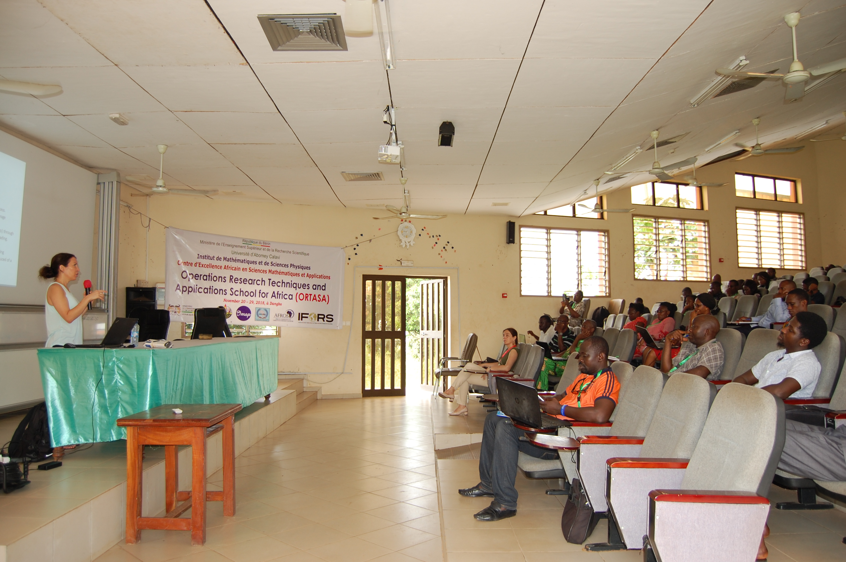 ***Dr Kathleen Vaillancourt, ORTASA, 2018***

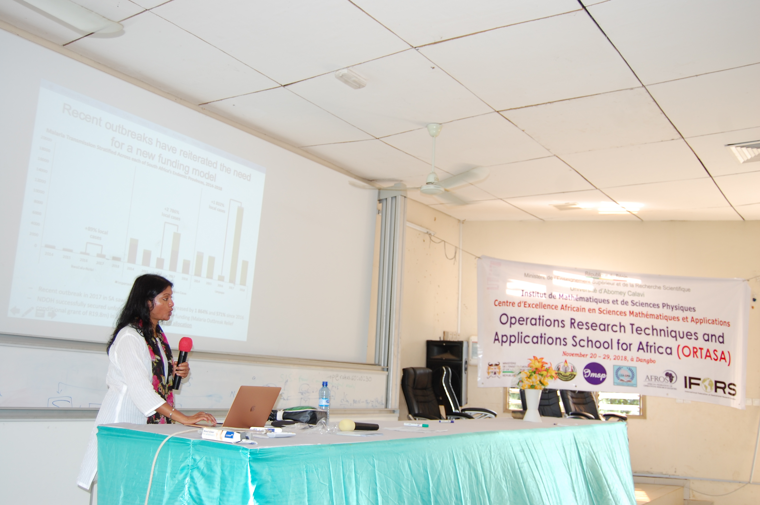***Dr Sheetal S. ORTASA, 2018***

**Online application:**

<https://bit.ly/30FgFOw>

**Grant:**

ACE-MSA will provide a limited number of grants. Priority will be given to female participants from West and Central African countries.

**Main sponsors:**

Institute of Mathematics and Physics Sciences / University of Abomey-Calavi / African Centre of Excellence in Mathematical Sciences and Applications/ Ministry of Higher Education and Scientific Research, Benin.

    